**Safeguarding Your Integrity:**

**Ethical Use (and Misuse) of Pastoral Power & Authority**

Definitions (power and authority from Merriam-Webster)

Definition of **Power**:

1. ability to act or produce an effect (the capacity or ability to influence or direct the behavior of others)

2. legal or official authority, capacity, or right

3. possession of control, authority, or influence over others

4. physical might; mental or moral efficacy; political control or influence

Synonyms: authority, control, dominion

Definition of **Authority**:

1. power to influence or command thought, opinion, or behavior

2. freedom granted by one in authority

3. persons in command

4. an individual cited or appealed to as an expert

5. convincing force

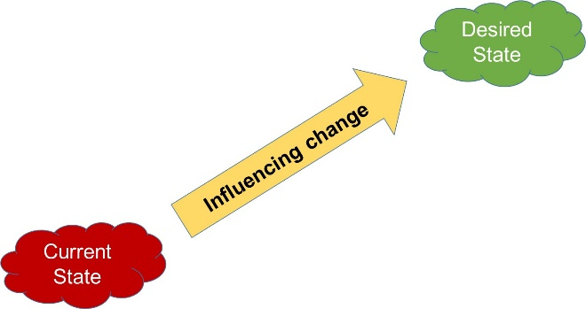

Influence can be by:

Push style of leadership

- urge, compel, drive, force, control, make, coerce, demand, intimidate, subdue,

or

Pull style of leadership

- convince, sell, show benefit, help see the right thing to do, give too much freedom

Ethical

- use correctly – in the way God specified

Serving God, leading others for God:

1. Must do the right thing

2. Must do it the right way (when specified, consistent with godly principles)

3. Must do it with the right motive – for the right reason

I. God is the source of power and authority

Psalm 62:11

Romans 13:1, 2

II. God delegates selected portions of His power and authority

A. God delegates a portion of His authority to roles, positions, organizations

Daniel 7:14, 27

Ephesians 1:21-22

1 Chronicles 29:12

Psalm 68:35

Genesis 50:19

B. Never gives anyone complete authority – delegates measured portion

Isaiah 42:8

1 Samuel 24:6

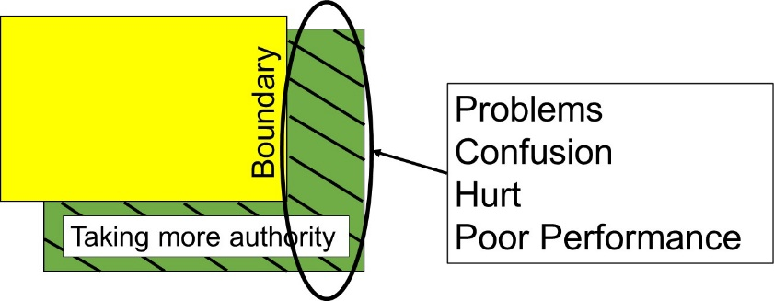

Example to think through boundaries of authority: Husband

**Ephesians 5:24**

III. Abuse of Power

The Scripture teaches a spectrum of increasingly harmful uses of power and then also examples of not using power you have been given when you should

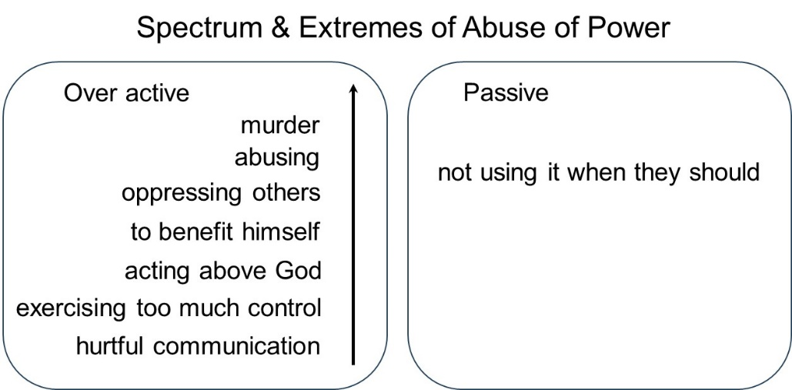

IV. How does God intend you to use the power & authority He delegates to you?

A. Empowerment

1 Corinthians 12:11

II Peter 1:3

Ephesians 3:20

Colossians 1:29

2 Corinthians 4:7

Acts 1:8

John 15:4-5

B. You are to use the P&A God delegates to you to accomplish the purpose He has given you and to help people become who He has called them to be

Romans 15:1

Isaiah 57:14-15

II Corinthians 10:8

V. Ways this actually works out

A. Abuse through exercising too much control

1 Samuel 2:9

Daniel 11:3

Mark 10:42

1 Peter 5:2-3

B. Not using the power and authority God has given when you should – passive

Genesis 16:2

1 Samuel 2:22-24

1 Samuel 3:13

Rule of thumb -- use the minimum amount of control necessary to do God’s will