**Ministry Leaders: A Helpful Examination of Several Critical Ethical Requirements Expected of You by God**

Introduction

A. Importance of character

1. Behavior (what we say and do) comes from the inner man

**Matthew 12:34-35**

**Matthew 15:17-20**

**Matthew 23:25, 26**

2. Character influences leaders

**Proverbs 16:23**

**Proverbs 22:11**

3. Lack of character of leader hurts others

**Ecclesiastes 10:16**

**Genesis 20:2, 9**

4. Masses benefit from righteous ruler

**Proverbs 28:12**

**Proverbs 29:2**

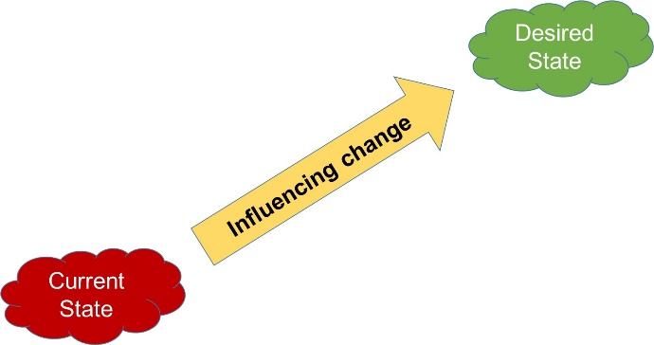

B. Leader Character

1. Wisdom is required for leaders

**Daniel 1:17**

**1 Kings 3:9**

**Proverbs 4:7**

**Proverbs 14:4**

**Ecclesiastes 9:14-18**

Wisdom comes from understanding and applying Scripture

1. Understand

2. Obey (Eccl. 12:13) – meditate to weave into your life

2. Integrity

**Psalm 89:34-36**

**Psalm 105:8**

**Proverbs 10:9-10**

3. Righteousness

Do the right thing

**Isaiah 56:1**

**Psalm 89:14**

**Proverbs 16:12, 13**

**Proverbs 14:34**

**Proverbs 10:2**

4. Justice

While related, justice is a step up from righteousness – even more complicated

Justice is what is fair, right, or should be without partiality, but also embodies mercy when it will benefit the person more than getting what they actually deserve.

**Isaiah 1:17**

**Isaiah 28:17**

**Micah 6:8**

**2 Samuel 1:14-16**

a. Leaders are not to bribe

**Proverbs 29:4**

**Isaiah 1:23**

b. Leaders are not to accept a bribe

**Proverbs 17:23**

**Deuteronomy 16:19**

c. Leaders are not to show partiality

**Leviticus 19:15**

**Deuteronomy 10:17**

5. Humility

**Proverbs 11:2**

**Psalm 33:16-17**

**Matthew 23:12**

6. Slow to Anger

**Exodus 34:6**

